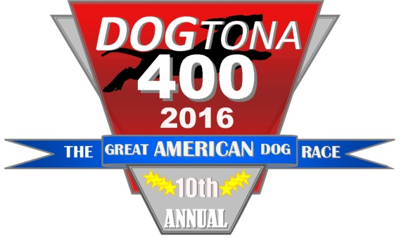

10th Annual Wiener Dog Race Registration
June 24th, 2015

About the Race
The 2016 Wiener Dog Race “DOGtona 400” fundraising event invites wiener dog owners from all over the region to showcase their dogs in a race with contests for speed and style. The race will be set up in the 400 block next to the popular Friday night “Farmers Market.” Food, drinks, children’s activities, and a raffle will round out the family-fun evening! All proceeds will benefit the Children’s Museum of Eastern Oregon.
Sponsors:

Rules and Regulations
- All dogs must have current shots. Please ensure your dog has the current DHPP, Rabies and Bordatella vaccines. (Parvo and Kennel Cough are highly contagious.)
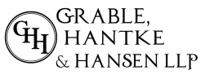
- All participating racing dogs must be a Wiener Dog. No mixed breeds will be allowed.
- Owners may bring their dog’s favorite toy.
- All dogs MUST be on a leash when on the premise. Leashes will be removed from pets once loaded in the starting gate. Upon completion of the heat, dog are required be leashed.
Breiling and Van Kirk,
Attorneys at Law
McBee
Surgical Clinic
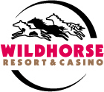
- Owners are required to clean up after their dogs.
- Dogs should be on their best behavior (i.e. no fighting or biting).
- Only one owner will be allowed in the racetrack area.
- No waving blankets or large items at the start of the race.

Additional info and signature required on back side

REGISTRATION
Registration form must be filled out by EVERY PARTICIPANT and turned in by Thursday, June 23rd to qualify for the $20 entry rate. Day of race registration is $25, pending room. This race is open to the first 40 dogs to register.

Owner’s Name: Dog’s Name:
Dog’s Gender: M F Age:
Address:
City: State: Zip Code:
Phone #: E-mail:
Payment Information:

Cash: Check: Credit Card: Visa MasterCard
Name on CC#: CC#:
Billing Address: Exp Date: Zip:

About the Children’s Museum Of Eastern Oregon
CMEO began in 1996 with the mission to provide children of all ages with opportunities for educational exploration and development through interactive exhibits and play. CMEO was created through the collaborative effort of over 300 community volunteers, and today has grown into an Eastern Oregon destination.

CMEO sparks inherent curiosity, creativity, and imagination in children of all ages. CMEO provides programs and interactive exhibits that go beyond the framework of entertainment to include both academic and real life skills. As the only Children’s Museum in all of Eastern Oregon, CMEO has a high impact on many children and families. With over 14,000 visitors and 150 memberships a year families, childcare providers, and educators throughout the region depend on CMEO.

The museum relies largely upon donations from the community and local businesses to provide these services. Thank you to everyone who continues to support CMEO!

The undersigned, ________________________________, hereby assumes all of the risks of participating in this activity or event, including by way of example and not limitation, any risks that may arise from negligence or carelessness on the part of the persons or entities being released and/or from dangerous or defective equipment or property owned, maintained, or controlled by them.
I release, waive and discharge from any and all liability, damage, losses or claims arising out of participation in or of my traveling to this event to support the Children’s Museum of Eastern Oregon (CMEO), whose address is 400 S. Main St., Pendleton, OR 97801, its employees and volunteers. I hereby agree to indemnify and hold harmless the Released Parties from any other activities connected with the Wiener Dog Race charity event for CMEO in which I may participate. I also give full permission for use of my names, the participating dog’s names, and/or photographs in connection with this event, and I understand that all entry fees are nonrefundable.
Children’s Museum of Eastern Oregon will not be responsible for any cost incurred for misbehaved dogs. I understand that the Children’s Museum of Eastern Oregon does not certify that other dogs are vaccinated and I am participating at my own risk.
I have read, understand, and agree to all the rules and regulations of the 9th Annual Wiener Dog Race. I waive any rights to and will not attempt to hold any party responsible if another dog bites my dog and/or me.
I certify that I have read this document and I fully understand its content. I am aware that this is a waiver, release of liability, and an indemnity contract, and that I sign it of my own free will.

Please sign:
(Registrations without signature will not be able to participate in the race.)

